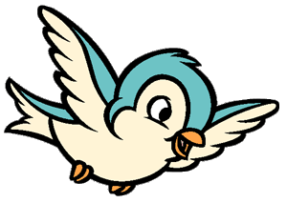
NATURE TOTS and
AUDUBON ACADEMY SCHEDULE
2020-2021

Nature Tots for Fall 2020
Thursdays from 9:30 to 10:45 a.m. Dates and topics are subject to change.
October 2020: Our 5 senses & Gardening
· October 1: Sight & Seeds
· October 8: *No Class
· October 15: Smell
· October 22: Touch
· October 29: Taste & Halloween Party

November 2020: Weather Patterns
· November 5: Seasons
· November 12: Weather
· November 19: The Sun’s Heat
· November 26 *No Class: Thanksgiving Holiday*

December: Habitats & Our Basic Needs
· December 3: Our Basic Needs
· December 10: Habitats Deserts & Ocean
· December 17: Habitats at PRAC (Wetlands)

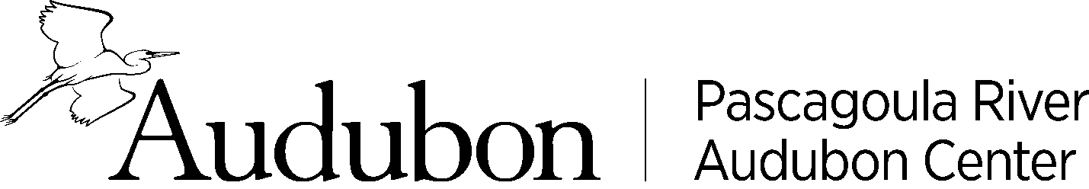

Audubon Academy
9 a.m. to 1 p.m.
Home School will be the fourth Wednesday unless noted in schedule. Dates and topics are subject to change.
- September 30: Getting to Know Birds, Part I
- October 28: Getting to Know Birds, Part II
- November 18: At Home in a Habitat
- December 16: Let’s Change Climate Change
- January 27 : Sharing our Shores: Beach birds, bees, bats, and other pollinators
- February 24 : Live Cycles of Birds
- March 31: Birds on the Move: Flight & Migration
- April 28: Earth Conservation and Stewardship
- May 19: Water and Water Science

