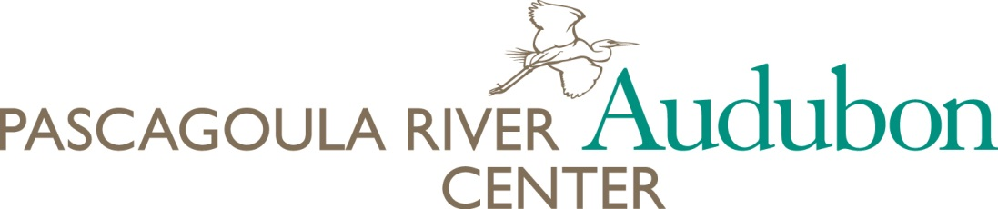
Pascagoula River Audubon Center’s Student Art Competition Artwork/Permission Form

Student Artist Name __________________________________________ Age_______________
Address____________________________________________ State_______ Zip ____________
Telephone ____________________________ E-mail Address ____________________________
School Name___________________________________________________________________
This form, when signed by the student’s parent or guardian, confirms that you hereby assign to Audubon Mississippi royalty-free perpetual, non-exclusive license to use the artwork described herein, including all associated reproduction, distribution, and exploitation rights in any and all media, to reproduce the artwork in Audubon Mississippi slideshows, brochures, newsletters, and other Audubon Mississippi projects, including the Audubon Mississippi website, and to allow third parties the same breadth of rights. Furthermore, you represent and warrant that no part of your student’s artwork infringes upon or violates any copyright, trademark, or any other proprietary right of any third party (such as postcards or widely used photographs), and will indemnify Audubon Mississippi against claims brought by any third party claiming ownership of any such rights.

________________________________ ______________
Parent/Guardian Signature Date

________________________________
Parent/Guardian Name Printed

Name of bird species you have depicted: _______________________________________________

Please tell us a little about the bird you have depicted, including what it eats; what kind of habitat it needs; and what kinds of things might threaten this species, such as loss of its nesting habitat or pollution. Ask your teacher or a librarian at your library to help you find books to research your bird. Please use the back of this form if you need more space.

